
LABS 6 report
CSE341 INTERNET PROGRAMMING


Name: Yousef Amr Mohamed Hassen
ID: 22P0274
Screen shots




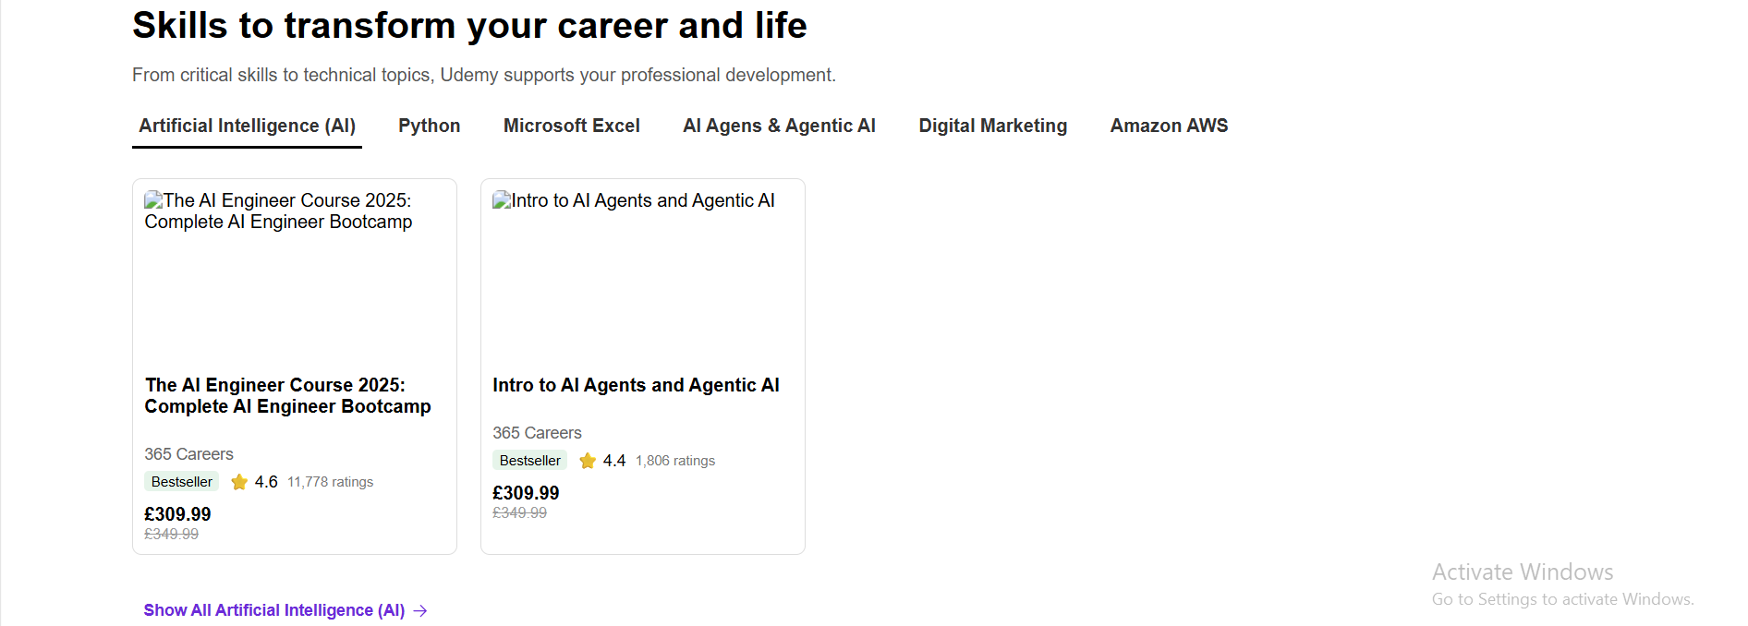



Github: https://github.com/kimjoesf/web-development-lab-projects.git

